0 | Brain Routine - Plain | 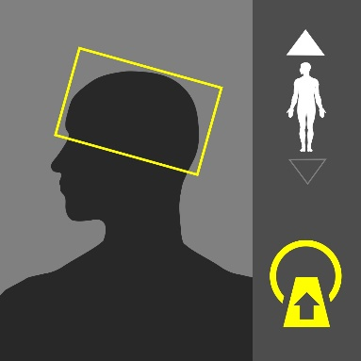
Purpose:
Evaluation of altered mental status, Congenital anomalies, hydrocephalus, hemorrhages, tumors, strokes, headaches, infections (usually IV contrast required), seizures (Contrast may be required), trauma, post-operative changes, Calcifications.

Instructions:
Use the image on the right as a guide. Cover the entire brain from foramen magnum to the vertex angled with the OML (base of the skull).
Dual Scanograms |  | 120kVp | 20mA

Patient Preparation
No preparation is required

Scan Details
Mode | Beam | Pitch | kVp | mA | Sure Exp. 3D | FOV
W-Volume | 0.5 x 80 | - | 120 | 280 | OFF | S

Procedure & Reconstruction Details
Phase | Coverage | Timing | Reconstructions (mm)
Plain | Below base of skull to vertex | - | Ax. 3X2  Cor. 3x3 (only if SOL)  Sag. 3x3 (only if SOL)

Algorithm Details
Brain | Kernel | FC68 | Filter | OFF | Boost | OFF | OSR | Head

Comments
- SOL implies tumors/ masses/ hematomas/ abscesses.
- Display window (WW/WL): 80/40

1 | Brain Routine with Contrast | 
Purpose:
Evaluation of mental status changes, hydrocephalus, hemorrhages, tumors, strokes, headaches, infections, seizures, trauma, or post-operative changes.

Instructions:
Use the image on the right as a guide. Cover the entire brain from foramen magnum to the vertex angled with the OML (base of the skull).
Dual Scanograms |  | 120kVp | 20mA

Patient Preparation
- Contrast media preparation is required.
- 22G -24G cannula is required.

Scan Details
Mode | Beam | Pitch | kVp | mA | Sure Exp. 3D | FOV
W-Volume | 0.5 x 80 | - | 120 | 280 | OFF | S

Procedure & Reconstruction Details
Phase | Coverage | Timing | Reconstructions (mm)
Plain | Below base of skull to vertex | - | Ax. 3X2  Cor.  Sag.
 | Volume: 50-75cc Rate: 1.5-2.0cc/s Delay: 75s
Brain +C | Below base of skull to vertex | 75s | Ax. 3X2  Cor. 3x3 (only if SOL)  Sag. 3x3 (only if SOL)

Algorithm Details
Brain | Kernel | FC68 | Filter | OFF | Boost | OFF | OSR | Head

Comments
- SOL implies tumors/ masses/ hematomas/ abscesses.
- Display window (WW/WL): 80/40

2 | Brain FAST / Trauma ** | 
Purpose:
Evaluation of hemorrhages, strokes, trauma, uncooperative patient who require urgent C T brain.

Instructions:
Use the image on the right as a guide. Cover the entire brain from foramen magnum to the vertex angled with the OML (base of the skull).
Dual Scanograms |  | 120kVp | 20mA

Patient Preparation
- Contrast media preparation is required (for Brain FAST only).
- 22G -24G cannula is required (for Brain FAST only).

Scan Details
Mode | Beam | Pitch | kVp | mA | Sure Exp. 3D | FOV
Volume | 0.5 | - | 135 | 350 | OFF | S

Procedure & Reconstruction Details
Phase | Coverage | Timing | Reconstructions (mm)
Plain | Below base of skull to vertex | - | Ax. 3X2 (brain), 3x3 (bone)  Cor. 3x3 (only if SOL), 3x3 (bone)  Sag. 3x3 (only if SOL)
 | Volume: 50-75cc Rate: 1.5-2.0cc/s Delay: 75s
Brain +C | Below base of skull to vertex | 75s | Ax. 3X2  Cor. 3x3 (only if SOL)  Sag. 3x3 (only if SOL)

Algorithm Details
Brain | Kernel | FC68 | Filter | OFF | Boost | OFF | OSR | Head
Bone |  | FC30 |  | UE0 |  | OFF |  | Body

Comments
- SOL implies tumors/ masses/ hematomas/ abscesses.
- Brain FAST does not require contrast injection. Proceed to (Brain +C) phase only if clinically indicated

3 | Brain + Sinuses | 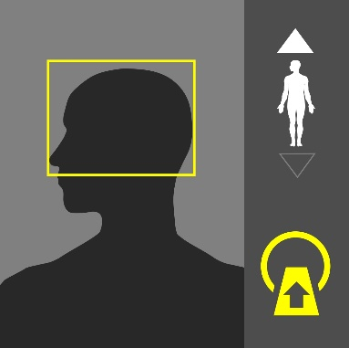
Purpose:
Evaluation of headaches, infections, or post-operative changes. Evaluation of infection, polyps, tumors, trauma and surgical planning.
Instructions:
Use the image on the right as a guide. Cover the entire brain from foramen magnum to the vertex angled without angulation
Dual Scanograms |  | 120kVp | 20mA

Patient Preparation
No preparation is required

Scan Details
Mode | Beam | Pitch | kVp | mA | Sure Exp. 3D | FOV
W-Volume | 0.5 x 80 | - | 120 | 280 | OFF | S

Procedure & Reconstruction Details
Phase | Coverage | Timing | Reconstructions (mm)
Plain | Below maxillary sinuses to skull vertex | - | Ax. 3X2 (brain), 0.5x0.5 (sinus)  Cor. 1x1 (sinus)  Sag.

Algorithm Details
Brain | Kernel | FC68 | Filter | OFF | Boost | OFF | OSR | Head
Sinuses |  | FC30 |  | UE0 |  | OFF |  | Body

Comments

6 | Sinuses | 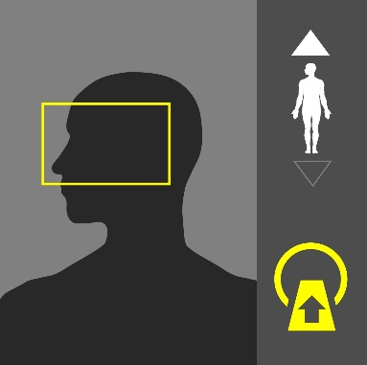
Purpose:
Evaluation of headaches, infections, or post-operative changes. Evaluation of infection, polyps, tumors, trauma and surgical planning.
Instructions:
Use the image on the right as a guide. Scan Cover from Maxillary sinuses through Frontal sinuses angled with the hard palate.
Dual Scanograms |  | 120kVp | 20mA
Patient Preparation
No preparation is required

Scan Details
Mode | Beam | Pitch | kVp | mA | Sure Exp. 3D | FOV
Volume | 0.5 | - | 120 | 200 | OFF | S

Procedure & Reconstruction Details
Phase | Coverage | Timing | Reconstructions (mm)
Plain | Below maxillary sinuses to above frontal sinuses | - | Ax. 0.5x0.5 (Sinus)  Cor. 1x1 (sinus)  Sag.

Algorithm Details
Sinuses | Kernel | FC30 | Filter | UE0 | Boost | OFF | OSR | Body

Comments

8 | IAM | 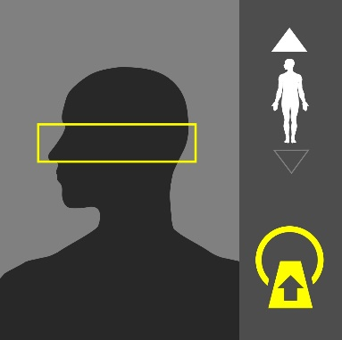
Purpose:
Evaluation of infection, tumors and congenital abnormalities of the external auditory canal, middle ear, inner ear, internal auditory canal and course of 7th cranial nerve.
Instructions:
Use the image on the right as a guide. Scan Cover from mastoid tip and finish at the top of petrous bone.
Dual Scanograms |  | 120kVp | 20mA

Patient Preparation
No preparation is required

Scan Details
Mode | Beam | Pitch | kVp | mA | Sure Exp. 3D | FOV
Volume | 0.5 | - | 120 | 200 | OFF | S

Procedure & Reconstruction Details
Phase | Coverage | Timing | Reconstructions (mm)
Plain | Below mastoid tip to above superior mastoid air cells | - | Ax. 0.5x0.5 (both)(R)(L)  Cor. 1x1(R)(L)  Sag.

Algorithm Details
IAM | Kernel | FC30 | Filter | UE0 | Boost | OFF | OSR | Body

Comments

9 | Orbits | 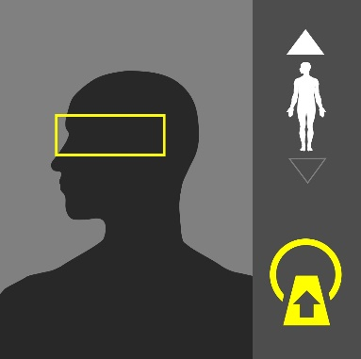
Purpose:
Evaluation of trauma, tumors, inflammation, infection and congenital abnormalities of the orbits, optic nerve and eye ball. Evaluation of raised intracranial pressure Cavernous sinus abnormalities.
Instructions:
Use the image on the right as a guide. Cover from the infra orbital rim tot the top of the orbits.
Dual Scanograms |  | 120kVp | 20mA

Patient Preparation
No preparation is required

Scan Details
Mode | Beam | Pitch | kVp | mA | Sure Exp. 3D | FOV
Volume | 0.5 | - | 120 | 200 | OFF | S

Procedure & Reconstruction Details
Phase | Coverage | Timing | Reconstructions (mm)
Plain | Orbits standard | - | Ax. 0.5x0.5(Soft HR)(Bone)  Cor. 3x3 (Soft HR)  Sag. 3x3 (R+L Soft HR)
 | Volume: 50cc Rate: 2.0cc/s Delay: 55s
Orbit +C | Orbits standard | 55s | Ax. 0.5x0.5 (Soft HR)  Cor. 3x3 (Soft HR)  Sag. 3x3 (R + L Soft HR)

Algorithm Details
Soft HR | Kernel | FC09 | Filter | AIDR 3D STND | Boost | OFF | OSR | Body
Bone |  | FC30 |  | UE0 |  | OFF |  | Body

Comments

10 | Facial Bones (Volume) | 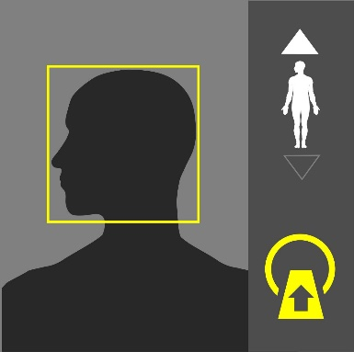
Purpose:
Evaluation of trauma, or post-operative changes.
Instructions:
Use the image on the right as a guide. Cover the entire head from below the chin to the vertex.
Dual Scanograms |  | 120kVp | 20mA

Patient Preparation
No preparation is required

Scan Details
Mode | Beam | Pitch | kVp | mA | Sure Exp. 3D | FOV
Volume | 0.5 | - | 120 | 200 | OFF | S

Procedure & Reconstruction Details
Phase | Coverage | Timing | Reconstructions (mm)
Plain | Hyoid to top of forehead | - | Ax. 0.5x0.5 (Bone), 3x3(Soft)  Cor. 3x3 (Bone)(Soft)  Sag.

Algorithm Details
Bone | Kernel | FC30 | Filter | UE0 | Boost | OFF | OSR | Body
Soft |  | FC09 |  | AIDR 3D STND |  | OFF |  | Body

Comments

4 | Brain CTA (C.O.W) | 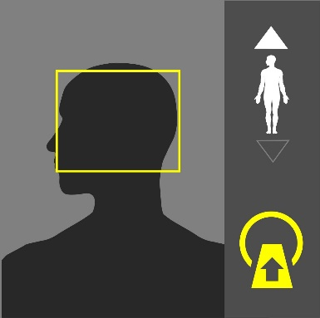
Purpose:
Examining blood vessel disease or related condition, Such as aneurysms or blockages.
Instructions:
Use the image on the right as a guide.
Dual Scanograms |  | 120kVp | 20mA

Patient Preparation
- Contrast media preparation is required.
- 18-20G cannula is required.

Scan Details
Mode | Beam | Pitch | kVp | mA | Sure Exp. 3D | FOV
Volume | 0.5 | - | 120 | 300 | OFF | S

Procedure & Reconstruction Details
Phase | Coverage | Timing | Reconstructions (mm)
 | Volume: 50cc Rate: 4.0-5.0cc/s Delay: SureStart
Brain CTA | 1cm below base of skull to vertex | Sure  Start | Ax. 0.5x0.5, 5x1 MIP  Cor. 5x1 MIP  Sag. 5x1 MIP

Algorithm Details
Brain CTA | Kernel | FC43 | Filter | AIDR 3D STND | Boost | OFF | OSR | Head

Comments

5 | Brain CTA (C.O.W) + Brain | 
Purpose:
Examining blood vessel disease or related condition, Such as aneurysms or blockages.
Instructions:
Use the image on the right as a guide.
Dual Scanograms |  | 120kVp | 20mA

Patient Preparation
- Contrast media preparation is required.
- 18-20G cannula is required.

Scan Details
Mode | Beam | Pitch | kVp | mA | Sure Exp. 3D | FOV
Volume | 0.5 | - | 120 | 300 | OFF | S

Procedure & Reconstruction Details
Phase | Coverage | Timing | Reconstructions (mm)
Brain Plain | 1cm below base of skull to vertex | - | Ax. 3x3 (brain)  Cor.  Sag.
 | Volume: 50cc Rate: 4.0-5.0cc/s Delay: SureStart
Brain CTA | 1cm below base of skull to vertex | Sure  Start | Ax. 0.5x0.5 (Brain CTA), 5x1 MIP  Cor. 5x1 MIP  Sag. 5x1 MIP

Algorithm Details
Brain | Kernel | FC68 | Filter | OFF | Boost | OFF | OSR | Head
Brain CTA |  | FC43 |  | AIDR 3D STND |  | OFF |  | Head

Comments

11 | Brain CTV (Venogram) + Brain | 
Purpose:
Examining Dural venous sinuses related condition, such as hemorrhagic infarctions, atypical infractions and headache/altered sensorium due to suspected Dural venous sinus thrombosis.
Instructions:
Use the image on the right as a guide.
Dual Scanograms |  | 120kVp | 20mA

Patient Preparation
- Contrast media preparation is required.
- 18-20G cannula is required.

Scan Details
Mode | Beam | Pitch | kVp | mA | Sure Exp. 3D | FOV
Volume | 0.5 | - | 120 | 300 | OFF | S

Procedure & Reconstruction Details
Phase | Coverage | Timing | Reconstructions (mm)
Brain Plain | 1cm below base of skull to vertex | - | Ax. 3x3 (brain)  Cor.  Sag.
 | Volume: 70cc Rate: 4.0-5.0cc/s Delay: 35-45s
Brain CTV | 1cm below base of skull to vertex |  | Ax. 0.5x0.5 (Brain CTV), 5x1 MIP  Cor. 5x1 MIP  Sag. 5x1 MIP

Algorithm Details
Brain | Kernel | FC68 | Filter | OFF | Boost | OFF | OSR | Head
Brain CTV |  | FC43 |  | AIDR 3D STND |  | OFF |  | Head

Comments

